JAZZ CONCERT POSTPONED

Out of consideration for their patrons and musicians, Laguna Live! has decided to postpone their Jazz concert scheduled for February 23. The new date is Wednesday, March 23.

Laguna Live! is delighted to be returning to the premiere event facility [seven degrees] for an evening with the Laguna Beach Live! All Stars, featuring acclaimed trumpeter Bijon Watson, with a jazz celebration of the music of Stevie Wonder.

The concert will be 6:00-8:00 pm with intermission. The doors open at 5:00 pm to enjoy social time with the bar open and pre-paid food bites. [seven-degrees] has created a new menu of enticing snacks to be enjoyed during the concert.
Health and safety protocols will be followed.

Tickets are $35 and Laguna Live! Members are invited to buy them now before they are open to the public on February 1.

Tickets will be available at www.lagunalive.org or by calling 949 715 9713 from February 1.

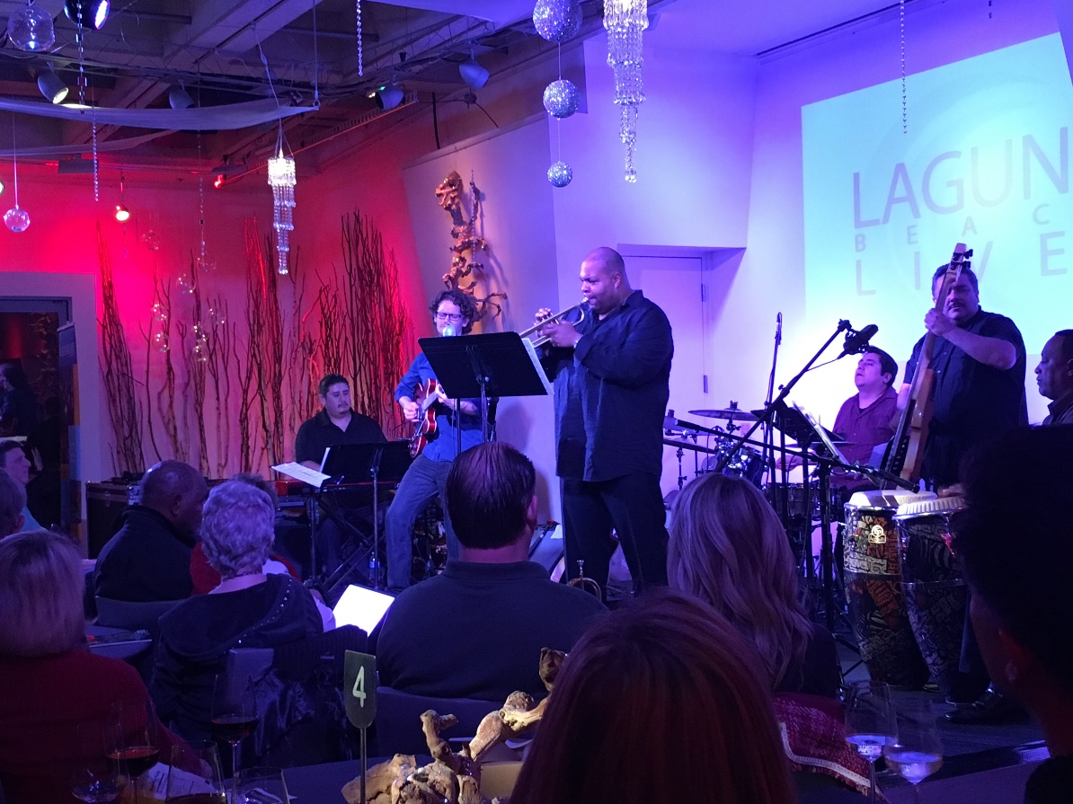
Bijon Watson performing for Laguna Live! at [seven degrees]
Photo courtesy of Ava Burton

