***FOR RELEASE***

Bluegrass & BBQ is Back

Tickets are on sale for Laguna Beach Live!’s Annual Bluegrass & BBQ. Taking place on Sunday, June 12, 4-7 pm, this Laguna Live! favorite returns to the picturesque grounds at Laguna College of Art and Design, 2222 Laguna Canyon Road, Laguna Beach.

The award-winning band, The Barefoot Movement will be performing. Also joining is local favorite Gnarly Q, who will serve up a delicious BBQ Buffet

Tickets: in advance:
$100 VIP (Includes: Concert, BBQ, reserved table and table service)
$40 Concert & BBQ.
$20 Concert only.
Available at www.lagunalive.org or by calling 949 715 9713

Non-VIP seating is theater style, first come, first served
Tickets at the door: $50 Concert & BBQ, $25 Concert only

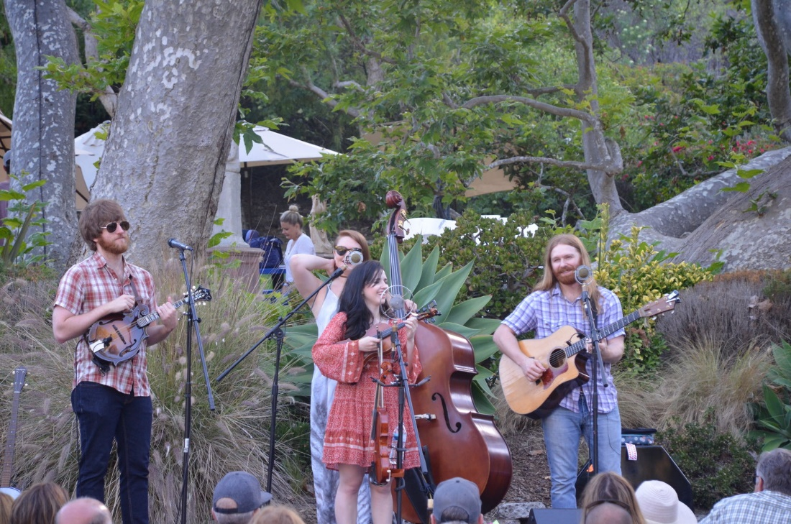
The Barefoot Movement at Bluegrass & BBQ 2018
Photo courtesy of Laguna Live

