***FOR RELEASE***

BETH’S TUESDAYS - May

Coming up on May 3rd, Laguna Live!’s monthly singer songwriter showcase, Beth's Tuesdays, will feature Steve Wood who will be playing selections from his new CD, "Junk Drawer" . Accompanying him will be Beth Fitchet Wood on bass and Suzanne Morrisette on percussion. Also appearing will be, award winning Charlie (Chuck) Roberts, playing, singing, and making you laugh.

Steve Wood, renowned musician, composer, and music director is bringing his many talents to Beth's Tuesdays. Wood is known as a founding member of HONK, a member of the local band 133, Music Director for Kenny Loggins, and composer for many MacGillivray-Freeman IMAX films. Chuck Roberts currently writes and performs for the TV show Dog Tales which is in its 8th season. He has written and performed for the Showtime mini-series “Wild Things” and also for various Movies. Winner of the SOCALMusicLive.com Male Acoustic Performer, Charlie tells stories with big wet hooks.

Venue: Laguna Beach Cultural Arts Center, 235 Forest Avenue, Laguna Beach
Time: 7 pm
Tickets: $10 in advance, $15 at the door and available at www.lagunalive.org

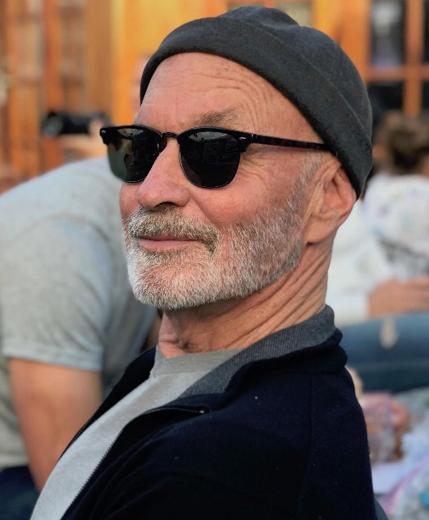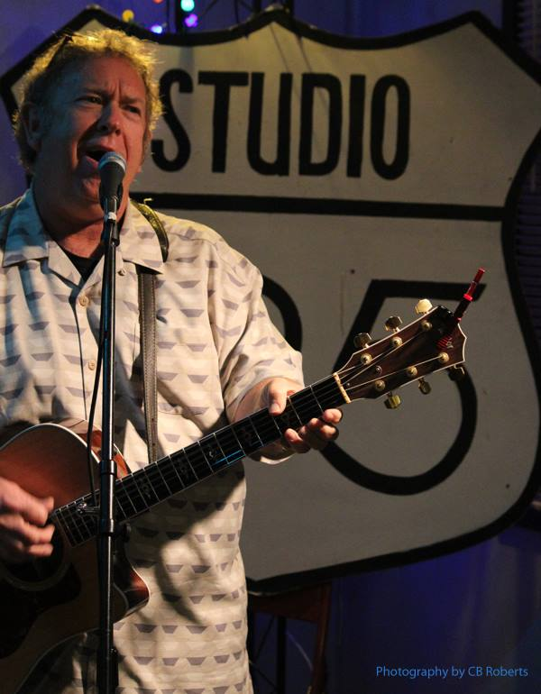
Steve Wood Chuck Roberts

