TICKETS NOW ON SALE

Tickets are now on sale to the public for Laguna Beach Live!’s Jazz concert on Wednesday, March 23. Laguna Live! is delighted to return to the premiere event facility [seven degrees] for an evening with the Laguna Beach Live! All Stars, featuring acclaimed trumpeter Bijon Watson, and a jazz celebration of the music of Stevie Wonder. The concert will be 6:00-8:00 pm with intermission. The doors open at 5:00 pm to enjoy social time with the bar open and pre-paid food bites. [seven degrees] has created a new menu of enticing snacks to be enjoyed during the concert.
Tickets are $35 in advance; $40 at the door, and are available at lagunalive.org or by calling 949 715 9713

Health and safety protocols will be followed.

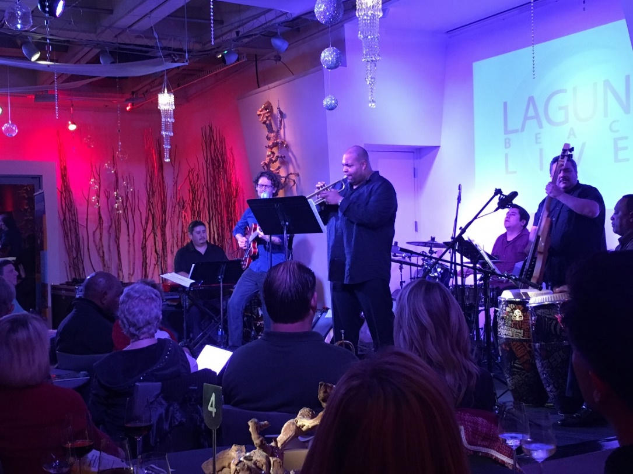
Bijon Watson performing for Laguna Live! at [seven degrees]
Photo courtesy of Ava Burton

